The challenge for my dvar this week is to take up the question that has recurred frequently during these zoom services. I remember rabbi matthew raising this question of horrible curses or actions taken by god against those who broke the covenant or commandments; barry gross and sara fox long and many of us regulars took up this same question: how can we relate to the torah, the foundation for our religion, when it contains horrible commandments that are so at odds with our progressive values today—attacks on lgbtq people or stonings of disobedient children or adulterous people etc. The list is long if we go back to the beginnings of the exodus where the pattern that runs throughout the tanakh from exodus down to this parshah, the ending of Deuteronomy, entails the description of the Israelites failing in one way or another to execute god’s orders, being punished, and then shuva-ing back again to being the god’s chosen people and being special or being rewarded with the promised land or god’s support in conquering other people.

It is a small move to recognize we are dealing with a god figure often, though not always, depicted as a war god whose primary attributes involve commandments, punishments for disobedience, power and conquest, destruction of enemies, violence that is red in tooth and claw, as the poet put it. When Christianity came along, it sought to portray itself as a religion of love, correcting this so-called flaw in Judaism, and we suffered from their hatred and violence directed against us, the remnant of historical jews, from the time of the roman emperors through the crusades and inquisitions down to contemporary antisemitism. Hatred and violence have clothed themselves in religious garb from the beginning of human history setting those of us who believed in our faith against those of others who believed in their gods and faith. This parshah is no different.

In line 15 of Nitzavim, chapter 29, we have:
15For you know how we dwelled in the land of Egypt, and how we passed among the nations through which you passed.
16And you saw their abominations and their repugnant idols [of] wood and stone, silver and gold which were with them.

The punishment for turning to the faith of others is severe, absolute, unforgiving, as the betrayal entails not only an error in judgment in choosing the wrong faith, but a sin, a wrong, an evil choice deserving of the worst of punishments.

17Perhaps there is among you a man, woman, family, or tribe, whose heart strays this day from the Lord, our God, to go and worship the deities of those nations. Perhaps there is among you a root that produces hemlock and wormwood.

Digging a bit into these two terms שֹׁ֛רֶשׁ פֹּרֶ֥ה רֹ֖אשׁ וְלַֽעֲנָֽה --a root producing hemlock and wormwood—yields some Wiki references to wormwood as associated with bitterness and cursedness. Wiki: “Wormwood is mentioned seven times in the Hebrew Bible, always with the implication of bitterness. The word wormwood is translated from the Hebrew term לענה (la'anah, which means "curse" in Hebrew).”
Rashi gives the same reading: a root that produces hemlock and wormwood: “a root that produces a bitter herb, like giddin. Here, then, the verse means:“[Someone who] produces and increases evil among you.”
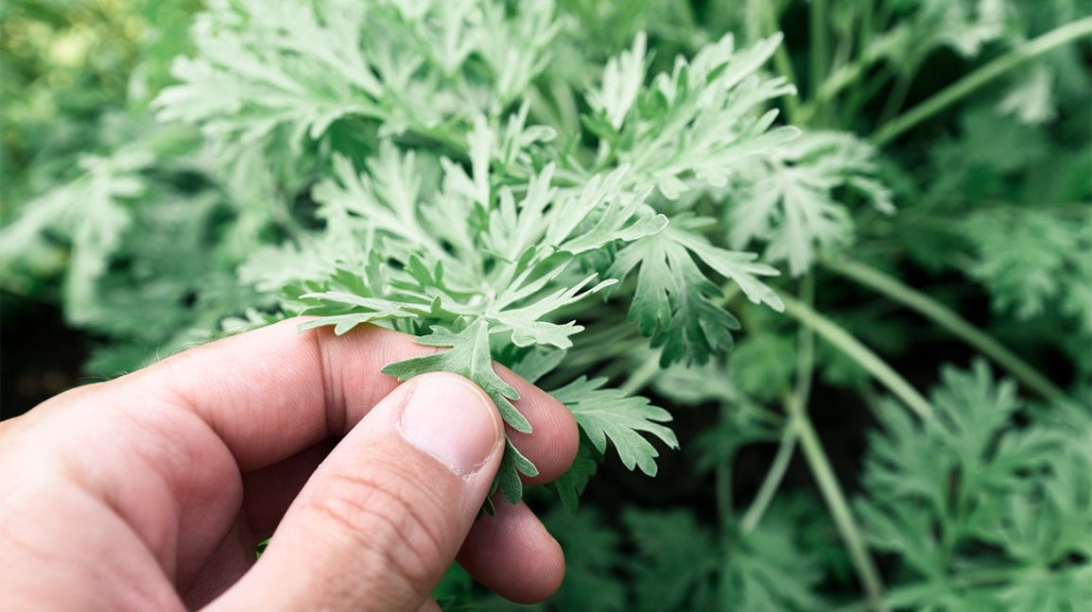
For Christians, this interpretation is augmented by the power of wormwood to embitter waters: Wiki: “Wormwood is mentioned only once in the New Testament, in the Book of Revelation: "The third angel blew his trumpet, and a great star fell from heaven, blazing like a torch, and it fell on a third of the rivers and on the springs of water. The name of the star is Wormwood. A third of the waters became wormwood, and many died from the water, because it was made bitter." (Rev 8:10–11)
The Greek word Apsinthos, which is rendered with the English "wormwood”, is believed to refer to a plant of the genus Artemisia, used metaphorically to mean something with a bitter taste. The English rendering "wormwood" refers to the dark green oil produced by the plant, which was used to kill intestinal worms. In the Book of Revelation, it refers to the water being turned into wormwood, i.e. made bitter.”
Nowadays, especially if we call on Betty Seagull, we are apt to learn of the restorative or medicinal value of wormwood.
As for hemlock, we all know Socrates chose to drink it rather than separate himself from the community, or perhaps rather than to choose a non-civilized life, or even a dissolute life.

It takes an enormous wrenching of the literal meaning of the text’s warning against those “whose heart strays this day from the Lord, our God, to go and worship the deities of those nations” to find some way to rescue the tanakh from the horrors of fundamentalism, be it jewish or muslim or Christian. KI practice involves not only a range of variants of jewish service, but buddhist meditation, and real efforts to join forces with our Christian and Muslim communities in Lansing. We are joined by beliefs that over and over profess common values and doctrines, and which always ask us to celebrate together by sharing in songs and prayers, events that have done us proud in a multitude of ways, not least of which is social zedakah.

I don’t wish to redeem the hemlock and wormwood by discovering their good medicinal practices, since they are evoked in the text metaphorically as embodying evilness and bitterness. They taste bitter, give death, destroy the good life-giving water. Their properties are tied to their root, their shoresh.

Let’s say, as Linda did earlier, we need to turn this unacceptable warning to a more positive reading, without eviscerating its own properties. For once, I’ll break my own rules against making safe and comfortable interpretations of hard passages. We can take a little bit of covid virus, turn it into a vaccine, and it protects us against the killing harm it can do us. We have to turn these violent war god views into vaccinations that can enable us to endure their prohibitions against encounters with others and against attempts to understand and incorporate their ways and beliefs. It is easier to hate the wargod injunctions and call them fundamentalist and backward. But to many other people we are equally fundamentalist in our vaunting of liberal values, and morally backward to those who see moral behavior in terms equally divided between sweet and bitter. The vaccination model calls for a little bit of hemlock, and little shot of wormwood; you can learn to like it, and be better off as a result.
Ok, this is getting too easy to swallow. Take the poison all the way and see what it does to us. That’s the full-throated revolt against the text, but maybe not for everyone. That’s the cure that kills the patient.

In fact, artemisia is the base of the current anti-malaria drug, and it comes from China. Maybe Trump should take it. Shabbat shalom. I don’t want to put trump into the same paragraph as shalom, but I can do it to vaccinate myself against his hateful beliefs. Shabbat shalom. God save us from fundamentalist prejudices. Third time. Shabbat shalom.

